# Tableau Tips

## Overall Tableau Tips

### Comment Fields

Fields in the data pane can have comments applied to them. These comments pop up when the field is hovered over to provide more detail on it.

1. Right click on any field in the data pane.
2. Choose *Default Properties*.
3. Click on *Comment...*
4. Type information into the comment and click OK

Now, when you hover over the field, information about that field appears.

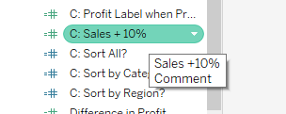

### Dissecting an Existing Build

Ctrl+E (⌘+E on Mac) will open up a dialog box describing the sheet you are on. It will give you a break down of all changes made to the sheet and where.

### Unicode

Unicode values (symbols, etc.) can be added in most places in Tableau. Copy and paste them into field names, calculations, sheet names, etc.

### Add Data to a Workbook

Most static file data (Excel, CSV, Access, etc.) can be dragged and dropped on Tableau to add that file as a data source.

### Bulk Format Changes

Formatting can be done on axis and labels, but also on a dashboard or the entire workbook at once. To do so, click on the *Format Menu* and choose *Workbook* (or *Dashboard*). This will grant you access to a new menu on the left allowing you to change default fonts and colors. As a warning, it is not advised to change default colors on fonts, as Tableau will adjust colors according to background in visualizations.

### Coloring Tabs

Tabs can be colored by right clicking on the tab and choosing a color. These colors appear when publishing to Tableau server.

### Naming Tab Sections

You can split up your workbook by section by simply adding a tab with some preceding characters. For example, you could name a tab ---Sales Section--- and place all your sales tabs following. This allows for simple navigation using the Window menu at the top.

### Repairing/Changing Tableau Interface

Tabs or panes in Tableau occasionally disappear, but can be restored using the pulldown in the toolbar at the top:



This menu lets you turn on and off all the various components of the Tableau screen.

## Visualization Based Tips

### Quickly Copy Data from Visualization

On any visualization in Tableau, you can copy and paste the underlying data. Open the chart, press Ctrl-C (⌘+C on Mac) to copy. Open Excel and paste the data.

### Add Calculations on the Fly

Any pill placed on a visualization can be double clicked. This opens an editable version of the pill, allowing you to add or change calculations on the pill within the visualization. If the calculation works and becomes something you may need/use again, you can CTRL-Click (⌘+Click on Mac) and drag it to the data pane to add it as a permanent measure or dimension.

### Duplicate & Duplicate as Crosstab

Any sheet in Tableau can be duplicated or duplicated as a crosstab. This allows you to create a copy of the sheet you are working on and modify it without fear of altering the original. Duplicate as crosstab is an excellent way to create a table of numbers for validation.

### Two Legends for Measure Names

When using measure names and measure values, you may want different color gradients for each measure, as the values for one measure may be far different than those of another (think of a value versus a percent). You can do this. Add *Measure Values* to color. This will apply a color gradient based on the values of the numbers. Once it is there, right click on the Measure Values pill that is on color and choose *Use Separate Legends*. This will all you to set a different color gradient for each measure.

**BEFORE:**

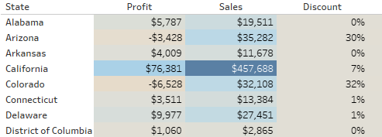

**AFTER:**

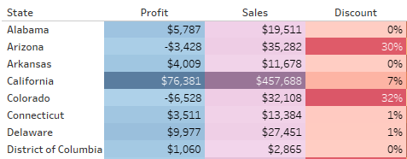

### Two Legends for Two Dimensions

You can apply two colors based on dimension as well. This is useful when one dimension is nested in the other. Here is how to set this up in Tableau:

1. Add the first dimension to color. This will color the chart based on this dimension.
2. Add the second dimension to detail. Assuming both dimensions are in the visualization, this should not impact how the visualization appears.
3. Click on the detail icon next to the second dimension and switch it to color.

**BEFORE:**

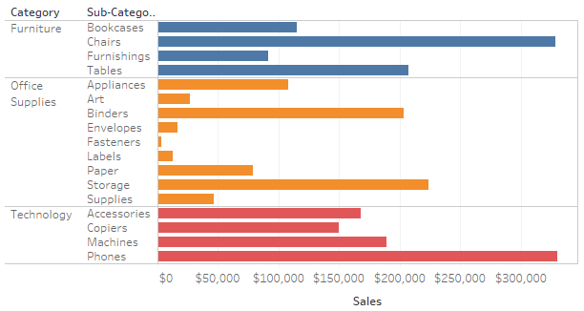

**AFTER:**

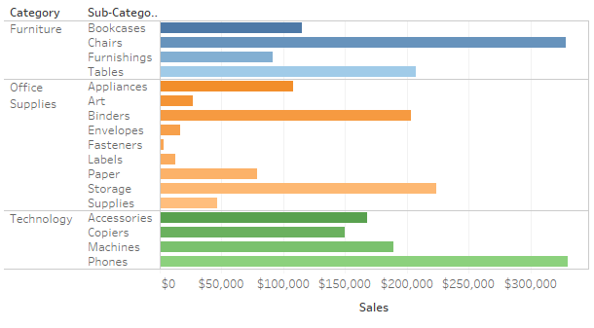

### Two Legends for Two Dimensions (Faster)

You can apply two colors based on two dimensions quickly. To do this, CTRL-Click (⌘+Click on Mac) both dimensions and while holding CTRL, drag the dimensions to color.

### Bring Highest and Lowest Values Forward

Sometimes, when you color a chart by a field, it sorts the data by name or by another dimension on the visualization. You can bring the highest or lowest points forward by sorting the color-by visualization. If you would like both the highest AND lowest fields brought forward, create a calc with the ABS(Measure). This makes an absolute value of the measure. Sort the detailed dimension by this absolute value field, and the low and high points will come forward.

**BEFORE:**

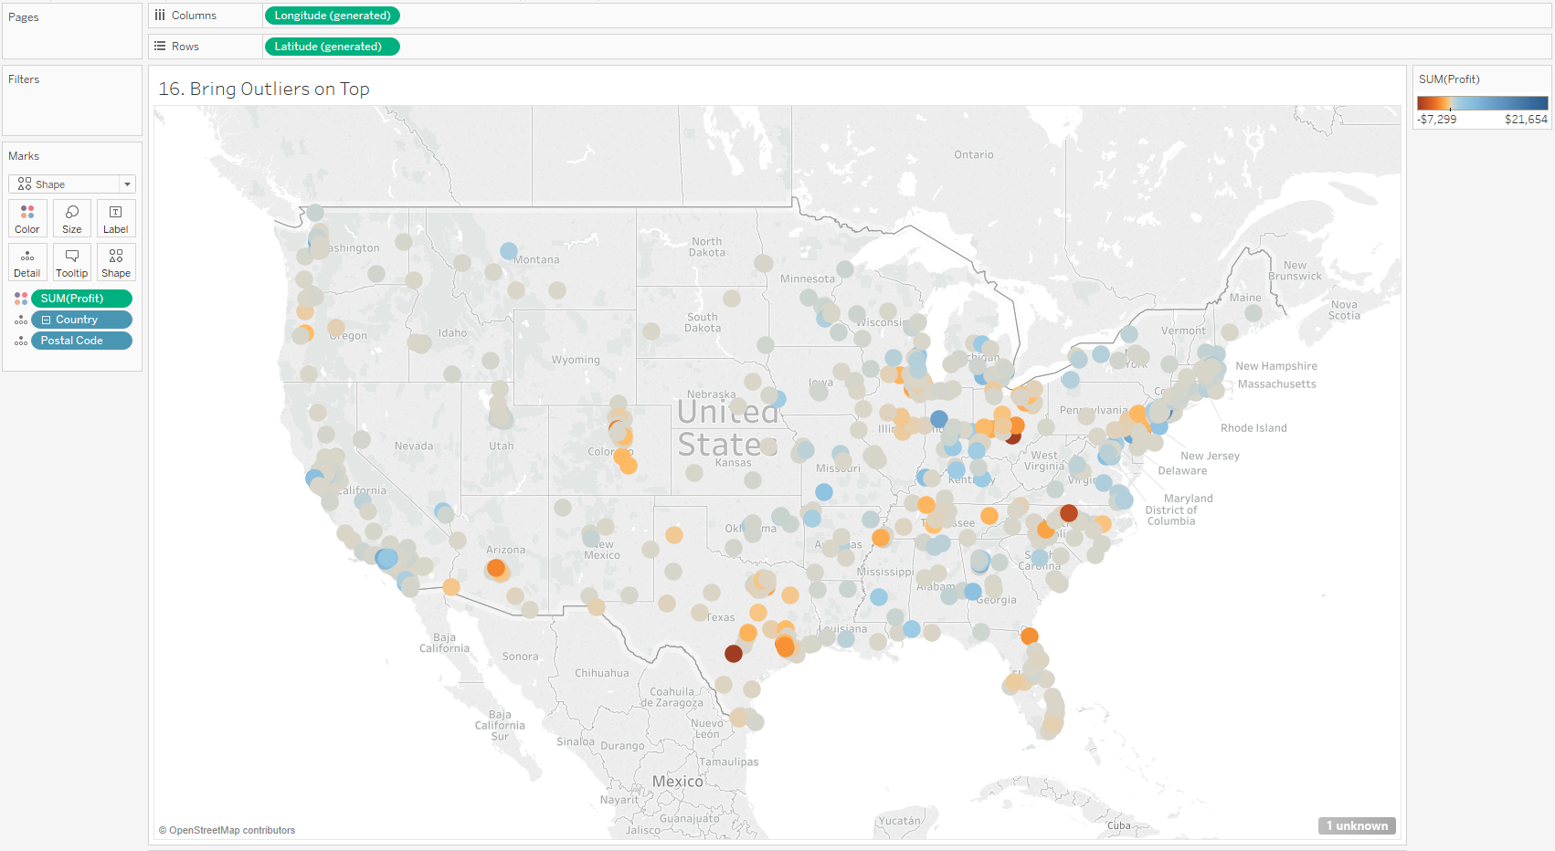

**AFTER:**

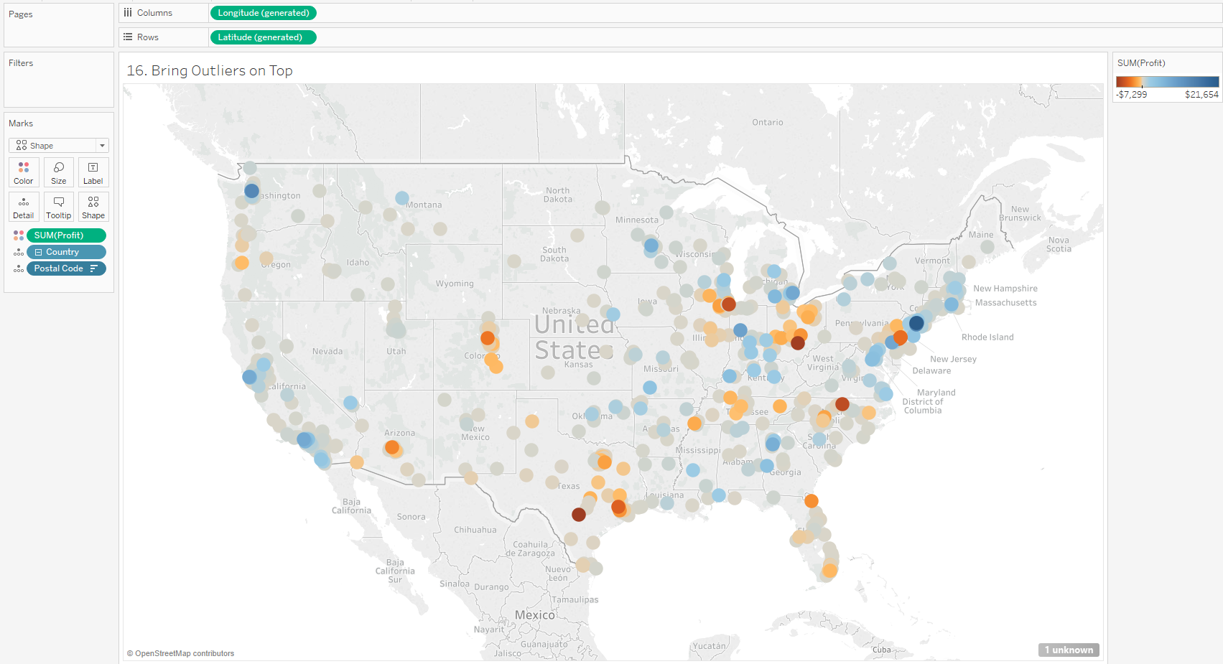

### Center Continuous Month Labels

Continuous month labels appear at the start of the month. That means that in bar charts, the label will appear on the far left of the bar. To fix this, do a quick calculation on the date field to add 15 days. This will push the label to the middle of the month. Changing the pill to +15 may require you to change the format of the label (try changing it to mmm or mmmm for months).

**BEFORE:**

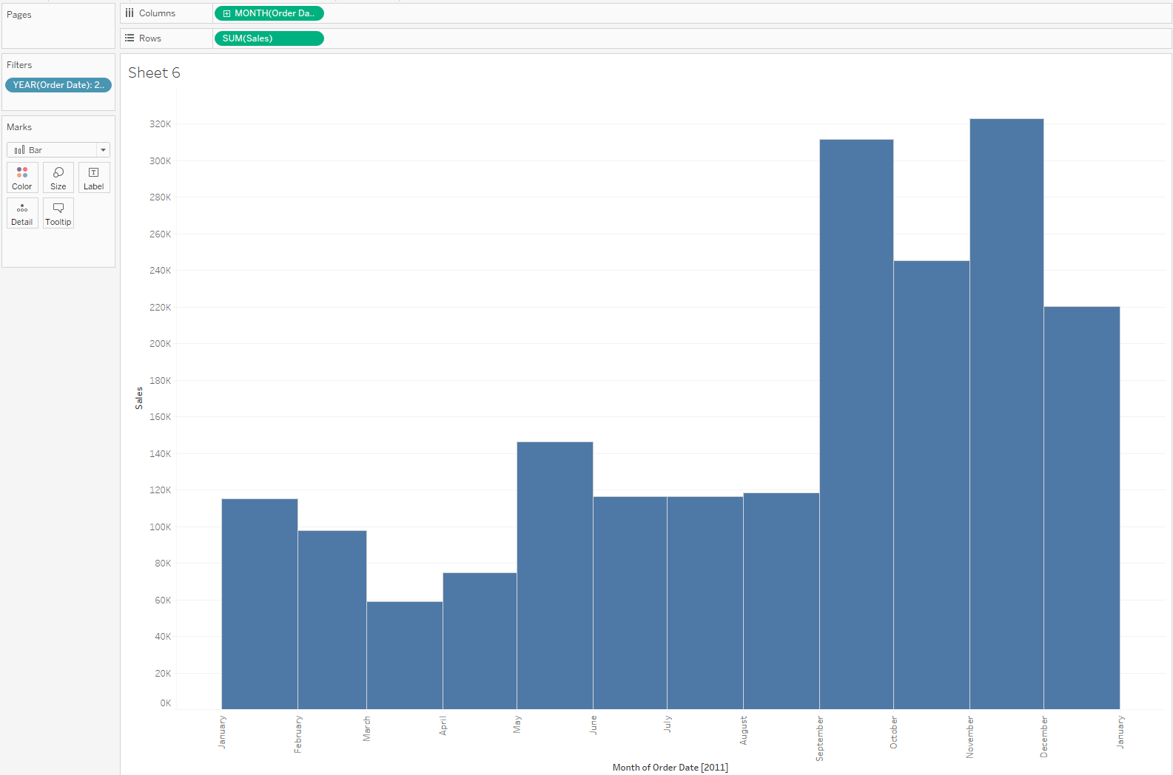

**AFTER:**

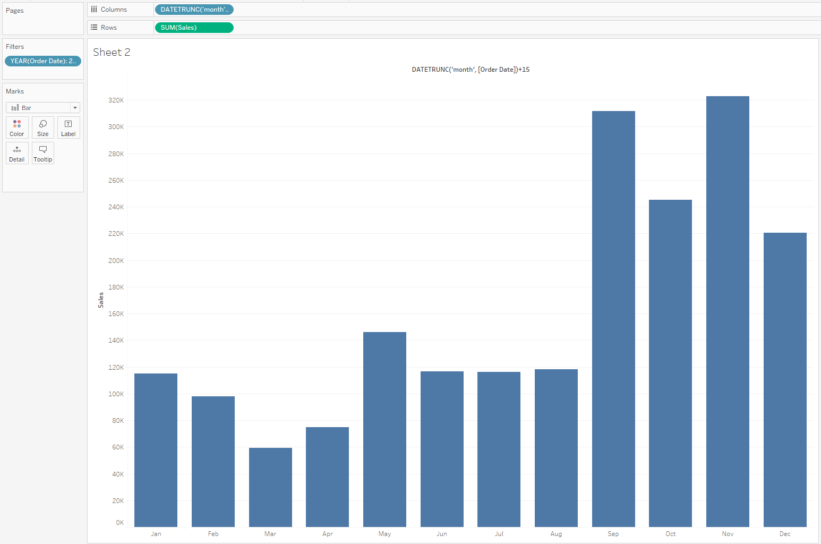

### Make an i-Note

iNotes are simple ways to provide additional information about a dashboard, such as data source, refresh, and explanatory information. They are simple to create:

1. Create a new worksheet
2. Drag measure names to rows or columns
3. Set the mark to shapes then change the shape to the i
4. Manually type information into the tooltip
5. Resize the i as needed
6. Remove headers and titles
7. Remove row divider

To make an easily-modifiable inote, place the information into a google sheet and make that the data source for the iNote. Have different iNotes per each dashboard in the workbook. Filter the iNote sheet to the dashboard you are applying to.

### Making the Label Appear in the End of a Bar

Sometimes you would like the label to appear at the inside end of the bar rather than outside the end or at the beginning.This is simple to do.

1. Duplicate the measure in the same row or column where it already appears
2. Dual axis and synchronize
3. Keep the first chart as bar with no labels
4. Make the second chart a shape and set the opacity to 0 on the color
5. Make sure the label is on the scatter plot
6. Change the label alignment to left
7. Adjust the font color if needed

**BEFORE:**

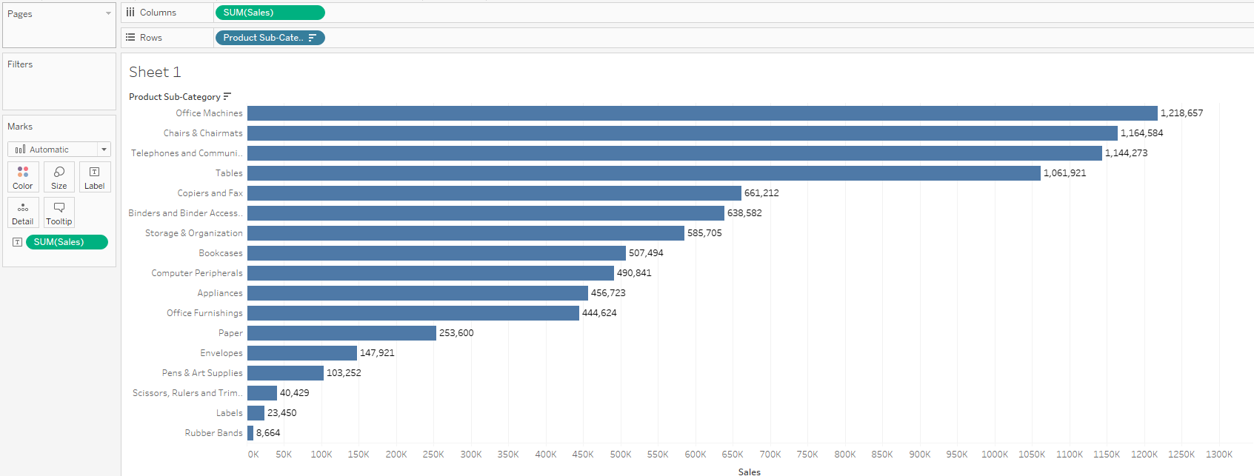

**AFTER:**

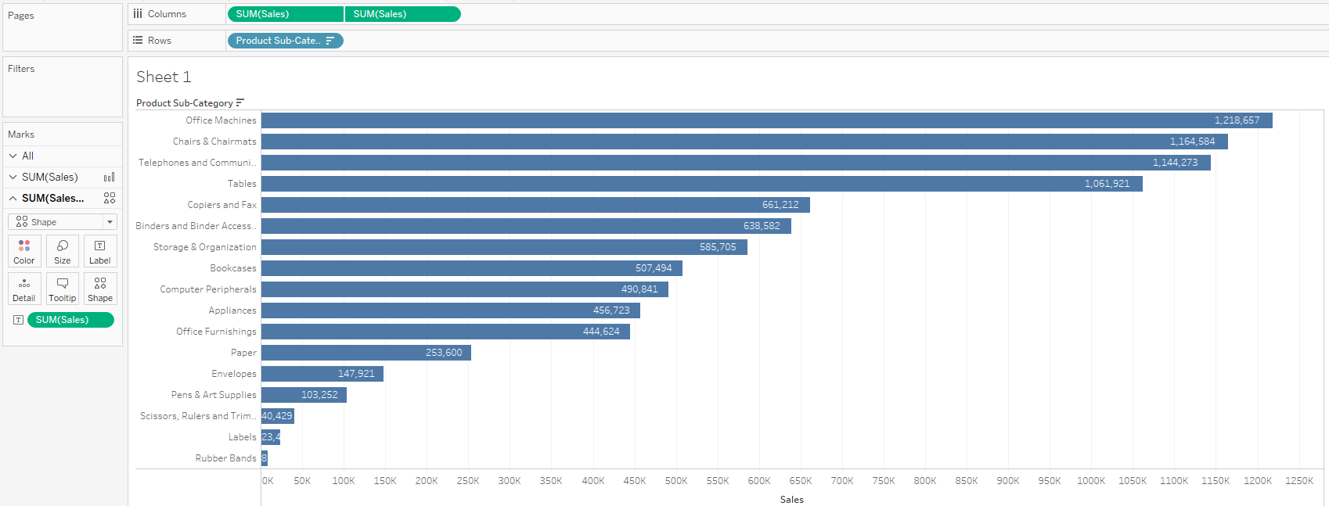

### Make a Dimension Geographic

In superstor data, there is a field called region, but Tableau does not recognize it as a geographic field. We can force tableau to use it as a geographic field by defining what other dimension it is comprised of:

1. Right clicking on the dimension and choosing geographic role
2. Click on “Create from”
3. Choose the field that the non-geographic dimension is composed of (states in this superstore example)

This allows you to use this field like a state or country and define a map.

### Jitter

Occasionally, data overlaps and makes it difficult to see the points. There are 2 ways to add jitter (disperse) the dots to make them easier to see in a visualization. In this example, we will use Profit by Order ID by Year from the superstore data set. Since there are so many orders, the points will overlap:

**BEFORE:**

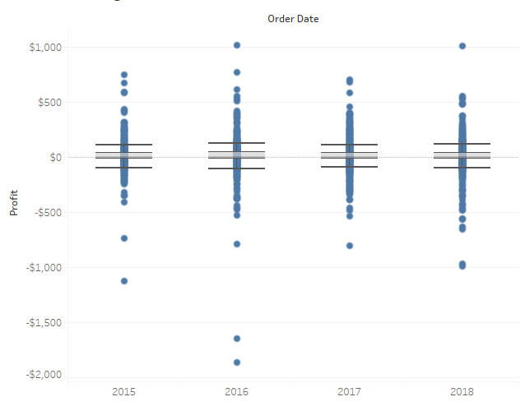

#### Option 1 - Use Random()

1. Double click to the right of the dimension. This should provide a pill that you can manually type a calculation in.
2. Type the following calculation: RANDOM() and press Enter

The drawback to this method is that while RANDOM() spreads the points out, it doesn’t do it evenly, and skews left, as seen in the after image below:

**AFTER 1:**

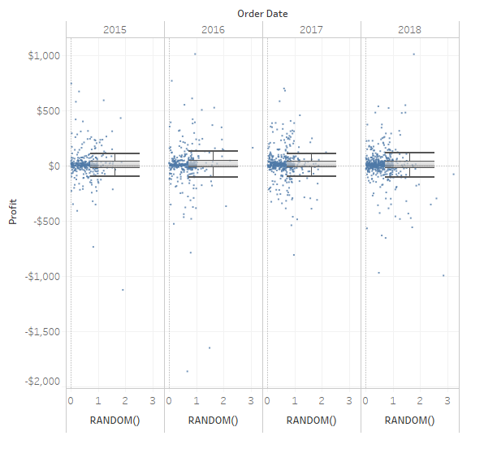

#### Option 2 - Use Index and Modulos

1. Double click to the right of the dimension. This should provide a pill that you can manually type a calculation in.
2. Type the following calculation: INDEX()%7
3. Right click on the new pill and tell it to calculate based on the detail (in this case, OrderID)

This calculation indexes every row and divides it by the number at the end. The modulos (%) returns the remainder. So, the data is split into an even number of columns. In this case, 7. The higher the number used, the more spread the points are.

**AFTER 2:**

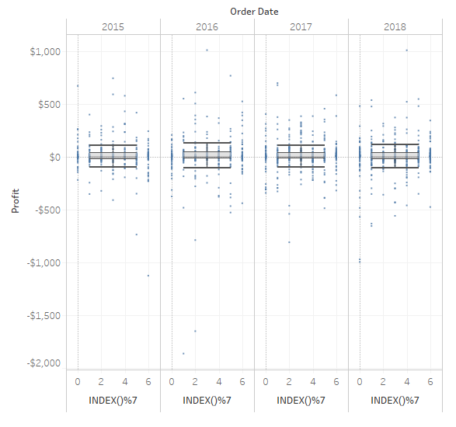

### Copy and Paste

You can select any or all points on a worksheet, copy, and paste them into a new worksheet or even into Excel.

### Set a Highlight as the Default Color Scheme

Sometimes, you may want to call out a specific point in the data. It’s obvious when you click on it, but it fades to part of the visualization when highlight is removed. You can keep a highlighted color scheme, though. To do so:

1. Build the visualization.
2. Assign a color palette
3. Make sure highlighting is on in the color legend
4. Click on the dimension you wish to highlight in the color legend
5. Once it is highlighted, click the pull down on the legend and choose Assign Highlight Colors to Palette

Now your worksheet is permanently set to highlight the data point or dimension.

### Missing Values

Sometimes there are date fields or other continuous data with missing points due to lack of data. You can sometimes recover these points (as 0s) by showing missing values. This option can be reached by right clicking on the axis and choosing Show Missing Values. The same option appears in the Analysis - Table Layout menu. *Example - Pull in Sales by MY(Order Date) filtered to Product Sub-Category Copiers and Fax*

### Stacking/Nested Bars

Bars can be stacked or not. In the case of a bullet chart, you may not want the bars to be stacked. You may want them to overlap. You can do this by going to the Analysis menu and choosing stack marks off. This will cause both bars to start at 0 and overlap each other. Additionally, add the dimensions/measures to size to make a bullet chart.

**BEFORE:**

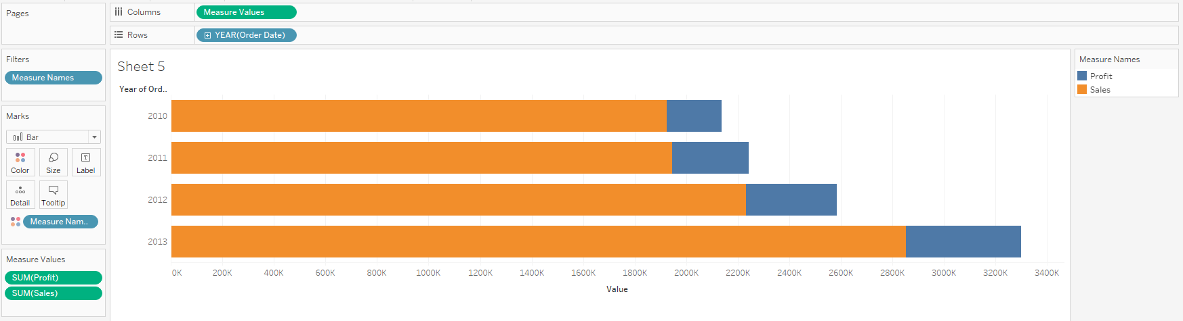

**AFTER 1:**

**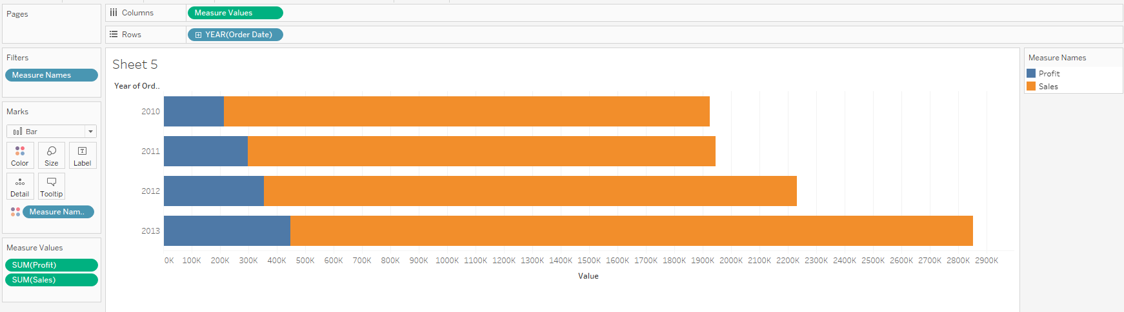  
AFTER 2:**

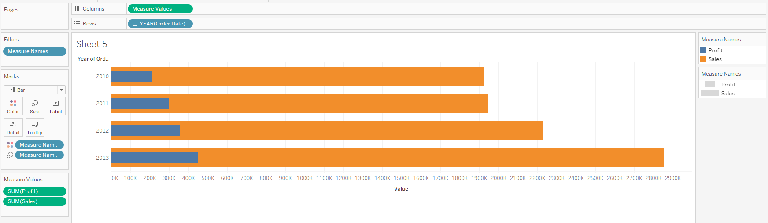

### Titles

Titles, by default, are the name of the tab. They can be changed by double clicking on them. A title can contain any of the fields or parameters used in the chart, and will dynamically change based on the fields included.

### Describe a Sheet

CTRL-E (⌘+E on Mac) will give you details about how the visualization is built. This is very useful when attempting to re-create a visualization. This option is also available in the Worksheet menu.

### Different Map Backgrounds

The map menu has multiple map backgrounds available to use. Offline mode removes map labels that appear in Tableau default, which may make for a cleaner layout if states is added to labels.

### Formatting

Right click any place on a visualization and choose format. This opens the format pane, allowing you to change fonts, alignment, color, fill, and more. Once the format menu is open, whatever you click on in the visualization will determine the format options on the left. You can also use the pull down to indicate which field you wish to change.

### Theme

You can change the defaults on fonts, colors, alignment, etc by choosing a Theme from the format menu. Default is Tableau font and Modern is Arial.

## Dashboard Tips

### Design for Multiple Layouts and Preview

When building a dashboard, you can design for other viewing tools such as phones or tablets. Clicking on the layout allows you to preview the version appearing on that device. You can then manually place things on the dashboard and design it the way you want to.

## Tableau Server Tips

### Custom Views

If you are working with a dashboard and come across a combination of filters and settings that are meaningful to you, you can save them. You can also tell Tableau server that you always want the dashboard to appear the way you have selected each time you open this dashboard.

1. Adjust the filters, parameters, and highlights to your preference.
2. Click on the icon to the upper right that says *View:Original*
3. A Custom Views window appears.
4. Give your new view a name
5. You can then choose to make it your default view of this dashboard and/or make it public for others to see.

To return to a custom view, click the same link at the top. Your new custom view should be available in the list of options to select. You can rename, change permissions, or delete a custom view by clicking the manage gear in that same window.

### Alerts

Any visualization with a numeric axis can be used to create alerts. This is extremely helpful when monitoring important numbers. You may want to be notified if a value goes above or below a certain threshold. To create the alert, 2 things must happen:

1. You must click on the chart you wish to set an alert for.
2. You must click on the axis that contains the number you are monitoring.

To set the alert, follow the steps above and then click the Alert button in the upper right.

1. Follow the prompts in the window that appears.
2. Set the condition and the value that will trigger the alert.
3. Type a subject for the email.
4. Set the frequency of emails based on the condition - this prevents too many emails from hitting an inbox if the condition remains true for an extended period.
5. Choose the recipients - you can enter a full name or a uniqname to find any faculty or staff member on the Tableau server.
6. Click Create Alert

The alert will send an email to the recipients detailing that the alert conditions that were met. It will also include a copy of the chart from which the alert was built.

### Preview Device Layouts

If you are a developer, you can preview how your chart looks on different layouts, such as phone or tablet. In Tableau server, click on the Preview Device Layouts link and choose the device you wish to preview. If the preview doesn’t look the way you want it to, go to your workbook in Tableau desktop and design for that device.